長庚大學資訊工程學系一百零九學年度上學期計算機概論課程小考3試題
上課班級: 一年甲班 授課老師: 林俊淵
受測範圍: C programming-Ch1-Ch5

- Please write a C program to solve the following problems:
- Please list three options for the users: (20%)
- Do the Sum with continuous numbers: (ex. 2 10)
Sum=2+3+4+5+6+7+8+9+10 =54
- Do the Fibonacci with several times: (ex. 10)
Fibonacci: 1 1 2 3 5 8 13 21 34 55
iii. Do the Product with continuous numbers: (ex. 2 10)
Product: 2*3*4*5*6*7*8*9*10=3628800
- User can input the choice. (20%)
- Do the action for one of options (i), (ii), (iii) and the show the result. (60%)
(i)  (20%) | 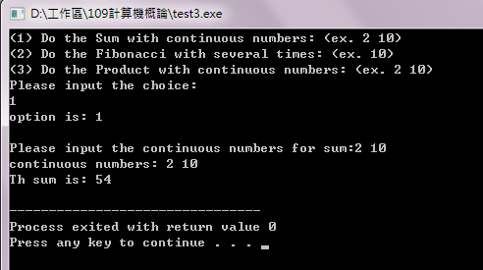
(ii)  (20%) | 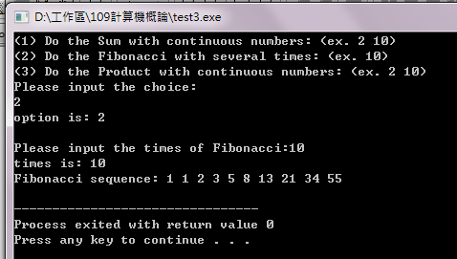
(iii)  (20%) | 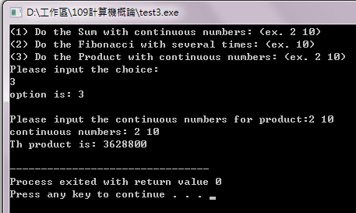

*Please upload (ftp) the Source code (*.c) to me.
*The file name should include your student ID. (ex. B0928014-test3.c)

